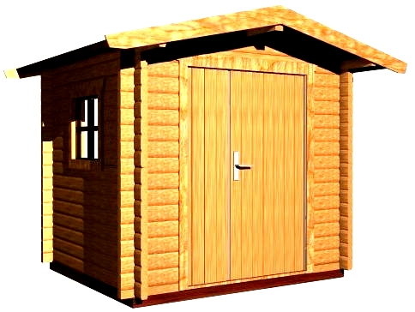

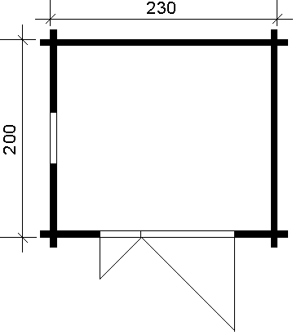
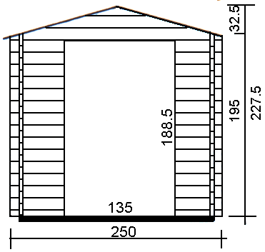
Consists of:

Walls: Sturdy 30 mm tongue and groove wall boarding from northern fir.

Flooring: 20 mm tongue and groove floor boards on the impregnated fundament frame. Floor fringes.

Roof: 20 mm tongue and groove roof boards on the roof beams.Overhanging canapy – 40 cm.
Roof coating is not included in the price.

Door: 1 unit 135/185.
The doors could be fully glazed, glass on top half or without glass.

Windows: 1 unit 50/62.
£620

